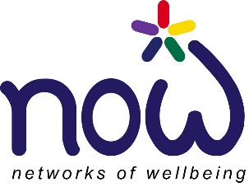


White Wood Fund

Deveron Arts and Networks of Wellbeing are offering grants of up to £200 to Huntly/AB54 community organisations and individuals to create an event or stage an activity in the White Wood on 28 May 2016.
The White Wood was planted by the community of Huntly in March 2015. It is located in the Bin Forest and is home to 49 oak trees, over 700 native trees and another 1000 of plants and herbs which will flower in white. The White Wood was planted in commemoration of WWI, as a space of remembrance, reflection and regrowth. The oaks, originally from Germany will grow for 300 years, live for 300 years and die for another 300 years.
The wood will officially be opened on 28 May during a day of celebration and events. Friends and strangers of all ages and from all places will be invited for exploration and conversation, stories and music, walks and talks, food and drink. A day of all things art, peace and ecology. The official opening ceremony of the White Wood will be conducted by Alex Salmond, MP.
We are inviting you to get involved by creating an event or activity for the White Wood opening that represents your community organisation. Funding can be used to schedule a one-off event involving community participation, or an all-day happening such as a stall or intervention.
Please contact info@deveron-arts.com for more information.

Deadline for applications: Monday 18 April, 5pm
Information Meeting: Thursday 14 April, 5.30pm, Networks of Wellbeing, Clashmach Centre

